# Media Analysis - No need to demonize ChatGPT but AI regulation is a must _ Arab News

## Short Summary

The article discusses the potential impact of ChatGPT, a powerful language model developed by OpenAI, on various industries including journalism in Saudi Arabia, highlighting both its benefits and potential threats, particularly in education and job sectors such as writing and journalism.

## Summary

1. ChatGPT, developed by OpenAI, is a powerful language model capable of understanding and responding to natural language, making it useful across various industries including journalism.  
2. The rapid advancement of AI technology, represented by ChatGPT, has sparked debates about its potential benefits and threats to humanity.  
3. In education, the use of AI like ChatGPT is causing concerns over cheating, plagiarism, and originality, leading to changes in teaching methods.  
4. There are fears that AI could disrupt professions such as journalism and medicine, raising questions about its impact on employment and the balance between human and artificial intelligence.

## Question 1

The article frames the public discussion about ChatGPT using metaphors that emphasize its potential impact and implications on various industries, particularly journalism, education, and healthcare.  
  
1. Revolution: The metaphor of revolution is used to describe how ChatGPT has the potential to transform the way news is consumed and produced in Saudi Arabia, suggesting a significant shift in the status quo.  
  
2. Threat/Existential threat: The article mentions that AI, including ChatGPT, is seen as an existential threat by some experts, referring to the possibility of AI outperforming human abilities and disrupting traditional employment sectors like journalism and education.  
  
3. Opportunity: On the other hand, the metaphor of opportunity is used to describe how AI could advance humanity if utilized properly. This idea emphasizes that ChatGPT can produce valuable content quickly and efficiently, freeing up time for humans to focus on more creative or complex tasks.  
  
4. Inequality: The metaphor of a great equalizer is employed towards the end of the article, suggesting that AI, specifically ChatGPT, could level the playing field for those who lack resources in various sectors, such as science and research.  
  
5. Demonization: Although not explicitly stated, the article does not demonize ChatGPT but instead presents it as a tool with both potential benefits and drawbacks. The discussion remains neutral and balanced, acknowledging both the positive and negative aspects of this AI model.

## Question 2

The text discusses various perspectives and aspects related to the use of AI, particularly ChatGPT, in different fields such as journalism, education, and even literature. It highlights both the potential benefits and concerns associated with this technology, such as its ability to generate content quickly and accurately but also the possibility of plagiarism, loss of jobs, and ethical issues related to copyright protection.  
  
However, there are some aspects that seem to be ignored or not explicitly mentioned in the text:  
  
1. The economic impact of AI on job markets and industries beyond education and journalism, such as manufacturing, logistics, and customer service.  
2. Privacy concerns related to the collection, storage, and usage of data by AI systems like ChatGPT.  
3. The potential role of governments, international organizations, or private companies in regulating and managing AI technology, including ethical guidelines and safety measures.  
4. Technical limitations of current AI models, such as their bias, lack of generalization abilities, and the need for large amounts of data to train these systems effectively.  
5. The long-term societal implications of widespread AI adoption on values, culture, and human interactions.  
  
In summary, while the text provides a balanced view of ChatGPT's impact on journalism, education, and literature, it does not delve into other related aspects like economic, privacy, regulatory, technical, or long-term societal implications.

## Question 3

Not mentioned. The article focuses on the impact of AI, particularly ChatGPT, in various sectors globally, but it does not specify any role or use of AI in the Arabic world.

## Question 4

The article emphasizes that while AI, specifically ChatGPT, holds immense potential for various fields including journalism, education, and even literature, it also poses challenges such as cheating, plagiarism, and loss of jobs. The final message is that AI regulation is crucial to ensure a balanced development where humans and AI coexist harmoniously, particularly in areas like education and journalism, and to prevent AI from becoming an existential threat.

## Sentiment

The sentiment is 3.0

## Entities

fed, OpenAI, AI, Springboard, Generative Pretrained Transformer, The Washington Post, READ Learning, Google, CNET, The New York Times, Midjourney, Disclaimer Views, Arab News, BBC, Amal Mudallali, Post

## Highlights

#7cc867#fb5b89#c885da#f9cd59

## Wordcloud for #7cc867 Highlights

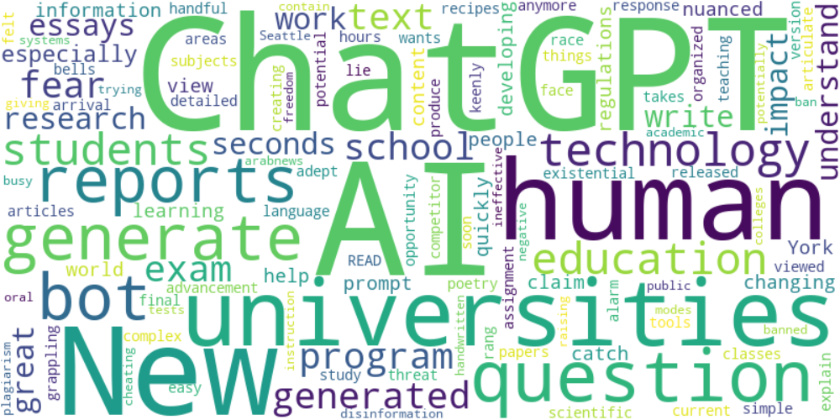

Top 10 words:

- ChatGPT: 9

- AI: 9

- human: 4

- reports: 3

- generate: 3

- bot: 3

- technology: 3

- education: 3

- universities: 3

- generated: 3

## Wordcloud for #fb5b89 Highlights

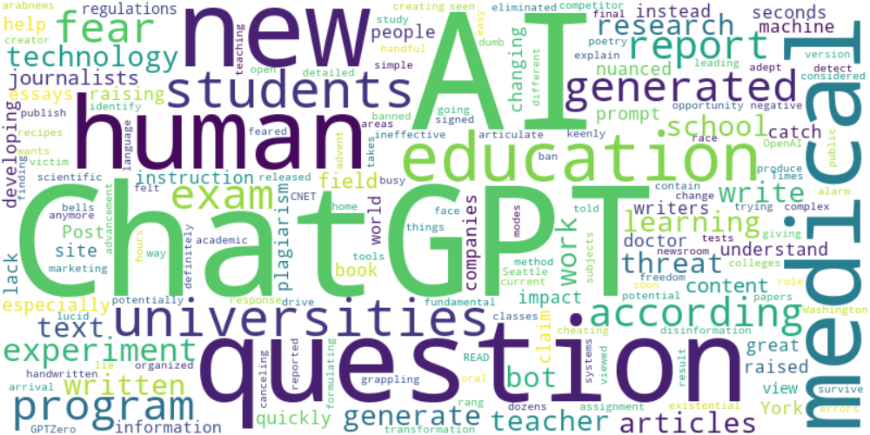

Top 10 words:

- AI: 18

- ChatGPT: 16

- human: 5

- education: 4

- question: 4

- generated: 4

- fear: 4

- questions: 4

- experiment: 4

- medical: 4

## Wordcloud for #c885da Highlights

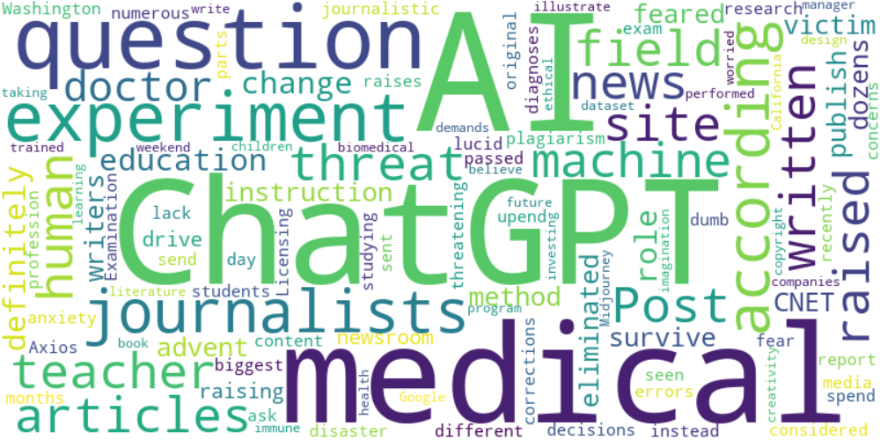

Top 10 words:

- AI: 9

- ChatGPT: 7

- experiment: 4

- medical: 4

- question: 3

- journalists: 3

- news: 2

- site: 2

- articles: 2

- according: 2

## Wordcloud for #f9cd59 Highlights

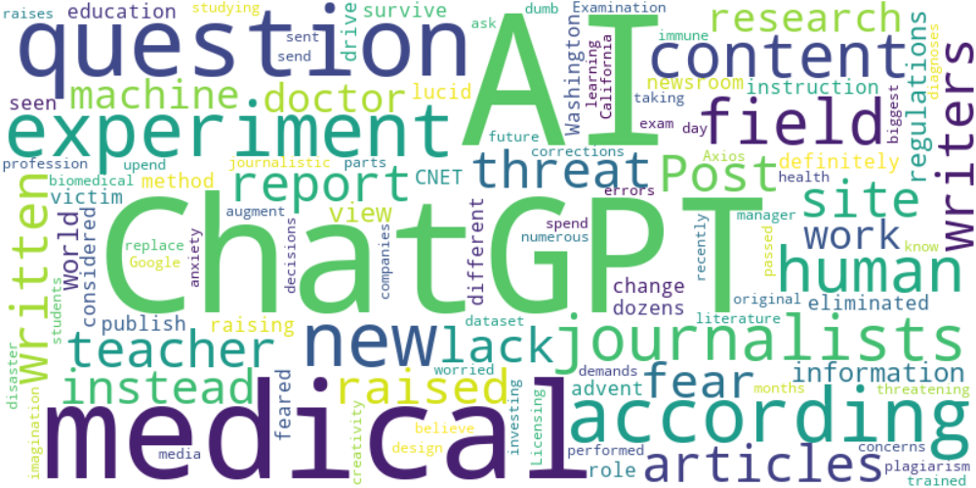

Top 10 words:

- AI: 12

- ChatGPT: 9

- experiment: 4

- medical: 4

- question: 3

- journalists: 3

- content: 3

- writers: 2

- news: 2

- site: 2